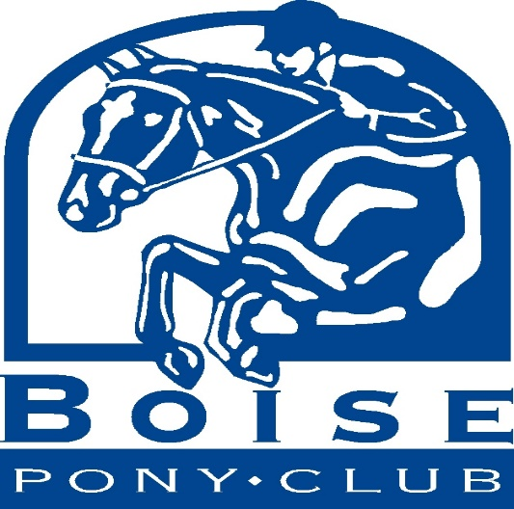

August 15, 2018

Business Name
Business Address

We are members of the Boise Pony Club, a local chapter of the United States Pony Club. The mission of Pony Club is to provide a program for youth that teaches riding, mounted sports, and the care of horses and ponies, thereby developing responsibility, moral judgment, leadership and self-confidence. In order to provide riding and competition opportunities, as well as instruction, our club relies on volunteers and fundraisers. On April 30, 2014 we will be hosting a Friends & Family Quiz Night with a silent auction. The event will encourage our non-equestrian friends and family members to participate in a fun-filled trivia challenge and potluck dinner. We are soliciting donations from area businesses for auction items. If your organization is interested in donating to this project we would greatly appreciate your contribution. This letter and our letter of Thank You indicating your exact donation are sufficient documentation of your donation for tax purposes.

All proceeds from the auction will be used by the club to pay for mounted instruction, rating examinations and our portion of the regional competition rallies. If you have any questions, please contact your mane and email. If you wish to have further information about the Boise Pony Club, please contact our District Commissioner, Kasey Krone at 208-921-2577. Our IRS 501(c)(3) tax number is 82-0386225. Thank you in advance for your consideration and support.

Sincerely,

Your Name
Boise Pony Club

